Network Architecture and Protocol Lab

Booklet 1
Submitted by: Jamil Ahmed
Neptun Code: JZT75Y

4.1
A) PC Parameters
• Processor cores: Intel Core i3-1315U, 6 cores (8 logical processors).
• Clock frequency: 1.20 GHz = 1,200,000 kHz.
Justification: Task Manager CPU Performance tab.
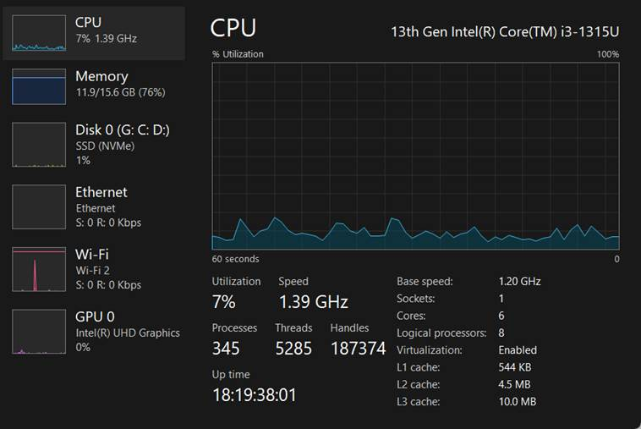

• Number and type of interfaces:
1. Ethernet Adapter
2. Wi-Fi Adapter
3. Bluetooth PAN
Total interfaces: 3
Justification: systeminfo command in Command Prompt.
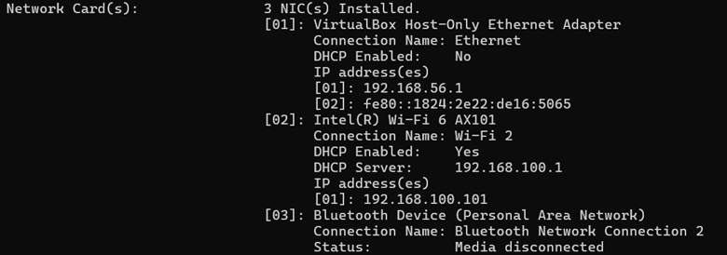

B) Mobile Phone Parameters
- Processor cores: 8-core Qualcomm Snapdragon processor.
• Clock frequency: 2.2 GHz = 2, 200,000 kHz.
Justification: Device Info app. App installed from Google Play Store.
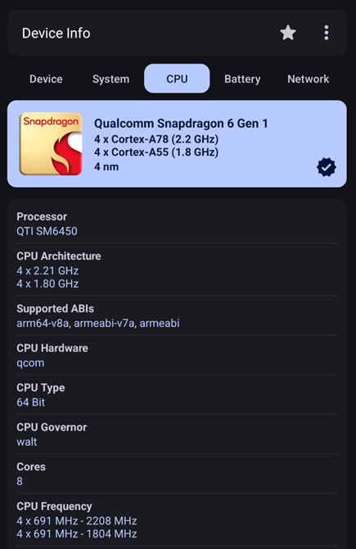

- Number and type of interfaces:
1. Wi-Fi
2. Mobile data (4G/5G)
3. Bluetooth
4. USB-C
Total interfaces: 4.
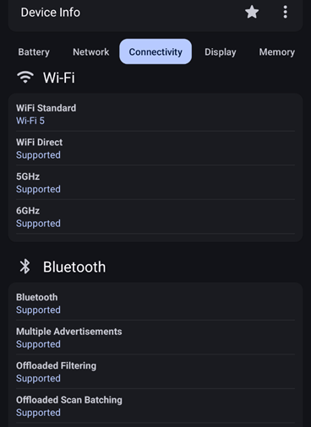
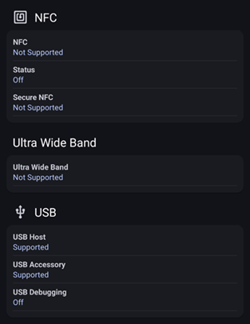
4.2
A) PC Operating System
• Type: Microsoft Windows 11 Pro.
• Version number: 25H2, Build 26200.7840.
Justification: System Properties in Settings.
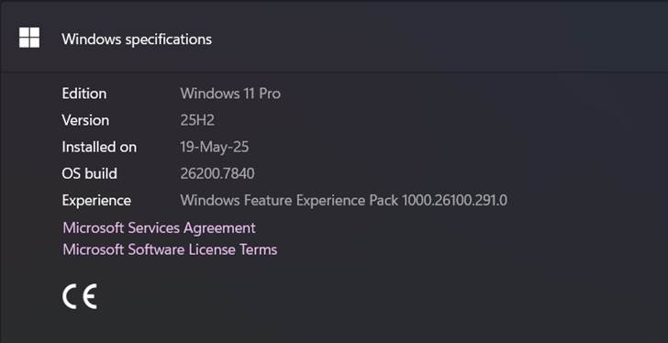

• Number of running processes: ~346 processes.
• CPU load: ~32%.
`Justification: Performance tab in Task Manager.
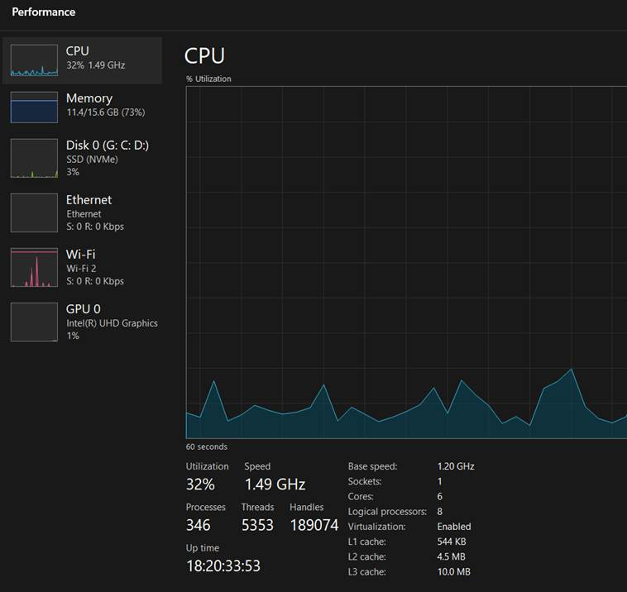

B) Mobile Phone Operating System
• Type: Android OS.
• Version number: Android 15.
Justification: Device Info App.
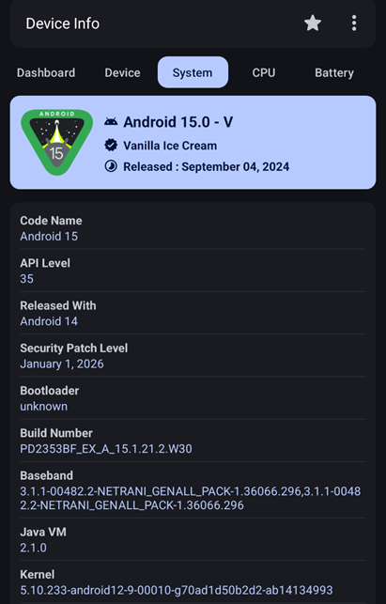

- Number of running processes: ~19.
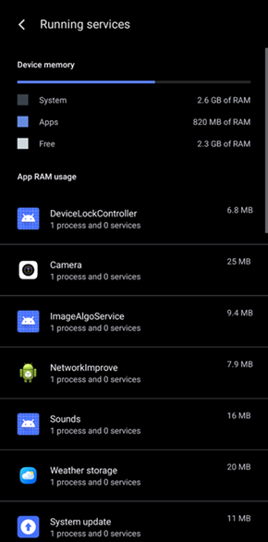
- CPU load: 3–6% idle, up to 40% during usage.
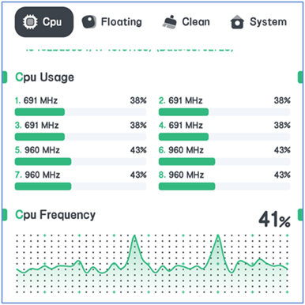

4.3
A) Arrangement of optical cable types in increasing order of size:
Single Mode Fiber (9 µm) < Multimode OM2 (50 µm) < Multimode OM1 (62.5 µm).
Justification: Ordering based on fiber core diameter.

B) Sensitivity of physical channel using NIC:
Wi-Fi frequency band: 5 GHz = 5,000,000,000 Hz.
Signal strength: ~62%.
Justification: typed the following command in Command Prompt: netsh wlan show interfaces
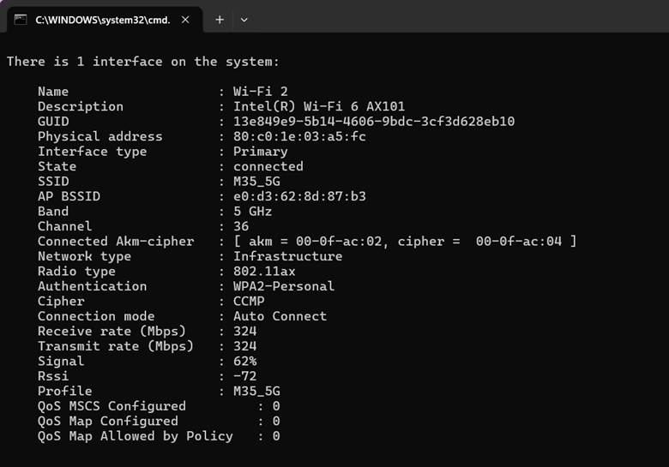

4.4
A) Dependence of speed on number of files:
n = 1 → 1250 MB/s
n = 2 → 952.4 MB/s
n = 5 → 892.8 MB/s
n = 10 → 862 MB/s
Justification:
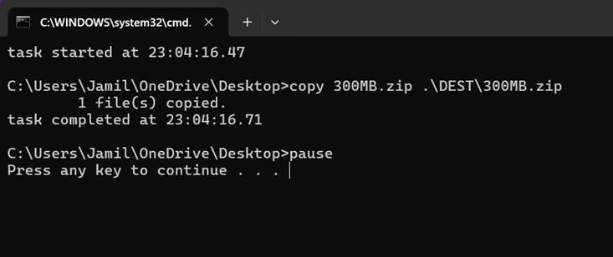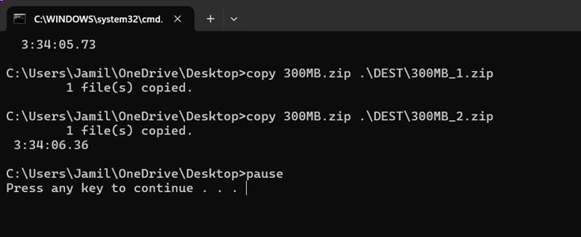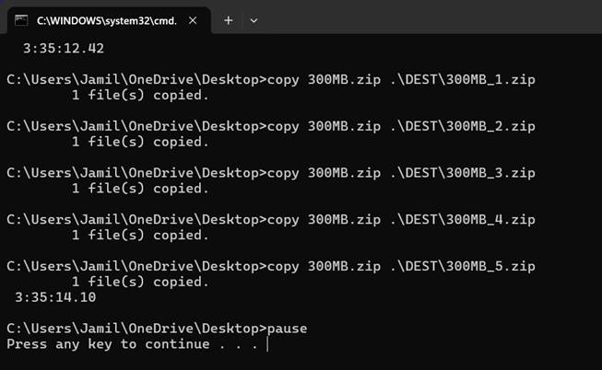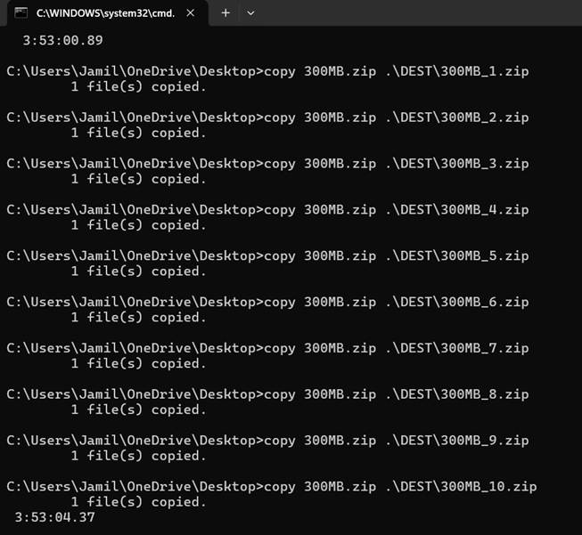
The equation to derive Bandwith:
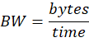
Conclusion: Bandwidth decreases as number of files increases.

B) Influence of file size on transfer speed:
L = 60 MB → 857.1 MB/s
L = 150 MB → 1363.6 MB/s
L = 300 MB → 833.3 MB/s
L = 500 MB → 2000 MB/s
Justification:
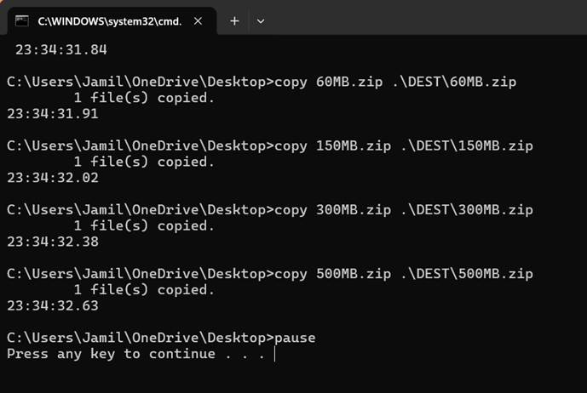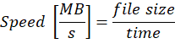
Conclusion: Bandwidth increases with file size.

